Misconceptions in Physics
Compiled from Gemini by Dan Jones, UK Physics teacher
Electricity

1. Circuit Models and Current Flow
- The Unipolar (Sink) Model: The belief that electricity only needs one wire to flow from the battery to a bulb. The second wire is seen as unnecessary or just a "safety" return.
- The Clashing Currents Model: The idea that "positive electricity" leaves one terminal and "negative electricity" leaves the other; they meet at the bulb and "clash" to produce light.
- The Attenuation (Consumed) Model: Perhaps the most common; the belief that current is "used up" by components. Students think there is more current before a bulb than after it.
- The Shared Current Model: The idea that current is shared equally among components (like bulbs in a series), but some is still "lost" or used up before it gets back to the battery.
- Sequential Reasoning: Thinking that a change made in a circuit only affects things "downstream" from that point, rather than the circuit as a whole system.

2. The Nature of the Battery and Energy
- Battery as a Constant Current Source: The belief that a battery always provides the same amount of current, regardless of what is connected to it. (In reality, it provides a roughly constant voltage).
- The "Empty Wires" Misconception: Thinking that wires are empty tubes and the battery "pumps" electrons into them. Students often miss that the wires are already full of electrons.
- Batteries Store "Electricity": The idea that a battery is a tank of electricity, rather than a source of potential difference that moves charges already present in the circuit.
- Recharging "Fills" the Battery: The belief that recharging a battery adds new electrons to it, rather than providing energy to reverse a chemical reaction.
- Voltage and Current are the Same: Using the terms "voltage," "current," and "electricity" interchangeably to describe a general "power" or "stuff" in the wire.

3. Resistance and Components
- Resistance is a "Struggle": Thinking of resistance as a physical obstacle that current has to "fight" through (which implies it loses speed), rather than a property that determines the rate of flow for the whole circuit.
- Adding Resistors in Parallel Increases Resistance: Applying the "more is more" logic of series circuits to parallel ones, not realizing that adding a path decreases total resistance.
- Distance Affects Brightness: The "Empirical Rule" that bulbs further away from the battery will be dimmer, regardless of the circuit type.
- Short Circuits are "Ignored": Believing that if a wire has no component on it, it doesn't "count" or have any effect on the rest of the circuit.
- The Switch "Creates" Electricity: Seeing the switch as the source of the energy rather than a gate that allows the existing system to move.

4. Advanced and Real-World Concepts
- Electrons Travel at the Speed of Light: Confusing the speed of the signal (the electric field) with the actual "drift velocity" of individual electrons, which is actually very slow (about 1mm per second).
- Static and Current Electricity are Different: Believing that "static" electricity (balloons, sparks) is a fundamentally different "substance" than the "current" electricity in a wall outlet.
- The Water Analogy is Perfect: Relying too heavily on the "water in pipes" analogy, leading to the belief that electricity will "leak out" of a broken wire onto the floor.
- All Wires are Insulated: Not understanding that the metal inside is the path; younger students often think the plastic coating is what "carries" the electricity.
- Protons Flow in Wires: The misconception that positive charges (protons) move through the metal lattice, rather than just the valence electrons.

Electricity Diagnostic Quiz
Name: ___________________________ Date: _______________
Instructions: Circle the best answer for each question.
1. A battery is connected to a single light bulb with two wires. If you measure the current in the wire leading to the bulb and the current in the wire returning to the battery, what will you find?
- A) The current is higher in the wire leading to the bulb.
- B) The current is the same in both wires.
- C) The current is zero in the return wire.
- D) The current depends on the brightness of the bulb.
2. Which statement best describes what is happening inside the copper wires of a circuit before the switch is closed?
- A) The wires are empty and waiting for electrons to be pumped in from the battery.
- B) The wires contain "static" electricity that turns into "current" electricity when the switch is flipped.
- C) The wires are full of electrons that are not yet moving in a specific direction.
- D) The wires are made of a special material that creates electrons when heat is applied.
3. In a series circuit with two identical bulbs, a student notices both bulbs have the same brightness. If they add a third bulb to the chain, what happens to the first bulb?
- A) It stays the same because it is "before" the new bulb.
- B) It gets brighter to compensate for the extra bulb.
- C) It stays the same because the battery always sends out the same amount of current.
- D) It gets dimmer because the total resistance of the circuit increased.
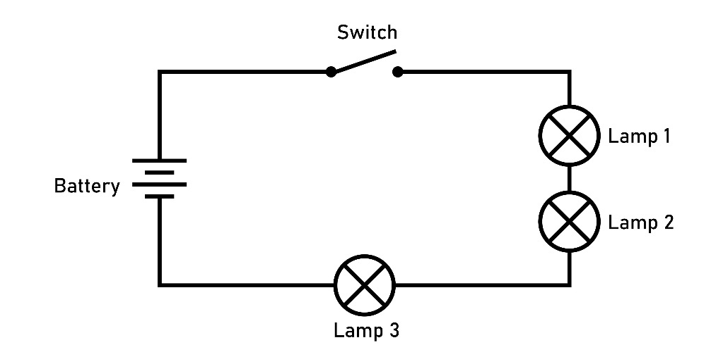

4. What happens to the total resistance of a circuit when you add a second path (a parallel branch) with another bulb?
- A) The total resistance increases because there are more bulbs.
- B) The total resistance stays the same.
- C) The total resistance decreases.
- D) The total resistance doubles.
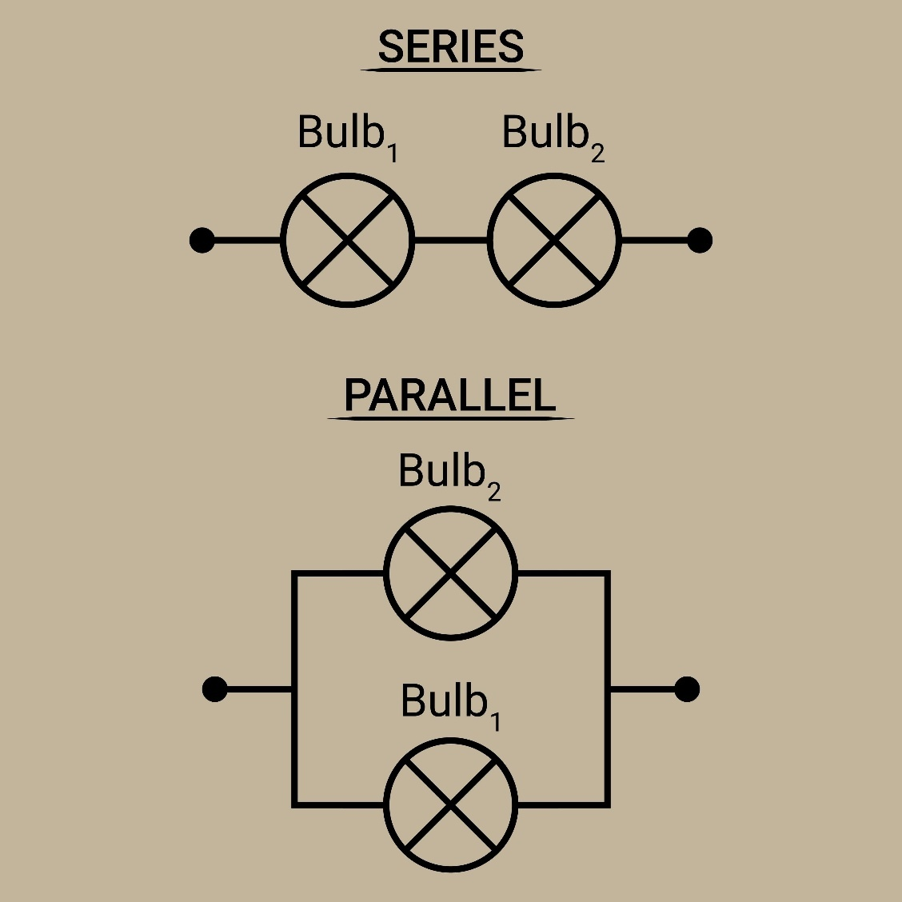

5. A student says, "The battery is like a heart pumping blood." In what way is this analogy misleading regarding current?
- A) It suggests the current flows in a loop.
- B) It suggests the battery produces the electrons, whereas it only pushes existing electrons.
- C) It suggests that there is pressure (voltage) involved.
- D) It suggests that the flow can be blocked.

6. Two identical bulbs are connected in parallel to a 9V battery. What is the voltage across each bulb?
- A) 4.5V for each bulb.
- B) 9V for both bulbs.
- C) 9V for the first branch and 0V for the second.
- D) It depends on which bulb is closer to the battery.
7. When a light switch is flipped, the light turns on almost instantly. Why is this?
- A) The electrons travel from the switch to the bulb at the speed of light.
- B) The bulb is already full of light and just needs to be "unlocked" by the switch.
- C) The electric field travels through the circuit at nearly the speed of light, moving all electrons at once.
- D) Electricity is a wave that doesn't require particles to move.
8. In the "Clashing Currents" model, how do students believe a bulb lights up?
- A) Electricity flows into the bulb from one side and is used up.
- B) Positive and negative electricity meet in the bulb and react together.
- C) The bulb resists the flow of a single type of charge.
- D) The battery pulls electrons toward it from both wires.
9. What is the primary function of the plastic coating around a copper wire?
- A) To prevent the charges from leaving the metal and to protect people from shocks.
- B) To provide a smooth surface for the electricity to flow over.
- C) To keep the electricity warm so it moves faster.
- D) To act as the primary carrier of the electric current.
10. If you disconnect a wire in a series circuit, why does the current stop everywhere immediately?
- A) The "electricity" leaks out of the broken end of the wire.
- B) The battery senses the break and turns itself off.
- C) The electrons at the break run back to the battery to warn the others.
- D) The circuit is no longer a complete loop, so the charges stop moving.

Q# | Correct | Misconception Identified by Incorrect Answers
1 | B | A: Attenuation model (current used up); C: Unipolar model (one wire).
2 | C | A: "Empty pipes" model; B: Static vs Current as different substances.
3 | D | A: Sequential reasoning; C: Battery as constant current source.
4 | C | A: "More is more" (Parallel vs Series confusion).
5 | B | B: Battery as a "store" or "creator" of electrons.
6 | B | A: Voltage sharing in parallel; D: Distance affects brightness.
7 | C | A: Particle speed vs Signal speed.
8 | B | B: Historical "Clashing Currents" model.
9 | A | D: Misidentifying the conductor vs the insulator.
10 | D | A: "Leaking" electricity; B/C: Anthropomorphising electrons.

Forces
1. Force and Motion (Newtonian Misconceptions)
- Motion implies a force: The belief that if an object is moving, there must be a force acting on it in the direction of motion.
- No force implies no motion: The idea that if an object is at rest, no forces are acting on it, or that if forces are balanced, the object must be stationary.
- Force is a property of the object: Thinking that an object "has" force or "carries" force within it (like a fuel), rather than force being an interaction between two objects.
- Velocity is proportional to force: The belief that a constant force is needed to maintain a constant speed, and that doubling the force will double the speed (rather than the acceleration).
- The "Impetus" Theory: Thinking that a force is "given" to an object (like a throw) and it gradually "wears off" or is "used up" as the object moves.
2. Gravity and Weight
- Gravity requires air: The misconception that gravity is caused by atmospheric pressure or that there is no gravity in a vacuum (or on the Moon) because there is no air.
- Heavy objects fall faster: The belief that weight affects the acceleration of free-fall in a vacuum, often due to confusion with air resistance.
- Gravity stops at the atmosphere: The idea that gravity only exists on Earth and doesn't act on satellites or the Moon.
- Weight and Mass are the same: Using the terms interchangeably; not realizing mass is the amount of "stuff" and weight is a force.
- Floating means no gravity: The belief that gravity does not act on objects that are floating in water or orbiting in space (confusing weightlessness with zero-gravity).
3. Balanced and Unbalanced Forces
- Reaction forces only exist for living things: The idea that a table doesn't "push back" on a book because the table isn't alive or moving.
- The "Active" force is greater: In a tug-of-war or collision, the belief that the winner or the "moving" object exerted a greater force than the other (failing to recognize Newton’s 3rd Law).
- Friction only acts on moving objects: Not realizing that static friction exists to prevent an object from starting to move.
- Equilibrium means no forces: The belief that "balanced" forces are the same as "zero" forces acting on an object.
- Centrifugal force is a "real" outward pull: The belief that an object in circular motion is being pushed outward by a force, rather than wanting to travel in a straight line (inertia).

4. Contact and Non-Contact Interactions
- Forces act only through touch: Difficulty conceptualizing how magnets or gravity can pull on something without physical contact.
- Air doesn't exert a force: The belief that air is "nothing" and therefore cannot push (upthrust) or pull (drag) on an object.
- Pressure and Force are the same: Not understanding that pressure is a force distributed over an area.
- Upthrust only acts in water: The belief that buoyancy doesn't apply to objects in the air (like balloons).
- Passive forces don't do anything: Thinking that "blocked" motion (like a wall stopping a person) isn't the result of a force being applied by the wall.

Forces Diagnostic Quiz
Name: ___________________________ Date: _______________
Instructions: Circle the best answer for each question.
1. A book is sitting perfectly still on a table. Which statement about the forces is correct?
- A) There are no forces acting on the book at all.
- B) The only force acting is gravity pulling it down.
- C) The downward force of gravity and the upward push of the table are equal.
- D) The book stays still because it has more "staying force" than gravity.
2. A ball is thrown up into the air. While the ball is moving upwards (after it has left the hand), what forces are acting on it? (Ignore air resistance)
- A) An upward force from the throw and a downward force of gravity.
- B) Only a downward force of gravity.
- C) Only an upward force from the throw.
- D) No forces are acting on it until it reaches the top.
3. If an object is moving at a constant speed in a straight line, what must be true about the forces?
- A) There must be a constant force pushing it forward.
- B) The forward force must be slightly larger than the friction force.
- C) The forces acting on the object are balanced (zero resultant force).
- D) The object is running out of force.
4. A heavy truck and a small car have a head-on collision. During the impact, which vehicle experiences the greater force?
- A) The truck exerts a greater force on the car.
- B) The car exerts a greater force on the truck.
- C) They both exert the exact same amount of force on each other.
- D) The vehicle that was moving faster exerts the greater force.
5. If you take a 1kg bag of sugar to the Moon, where gravity is much weaker than on Earth, what happens to its mass and weight?
- A) Both the mass and weight decrease.
- B) The mass stays the same, but the weight decreases.
- C) The weight stays the same, but the mass decreases.
- D) Both stay the same because the bag is sealed.

6. Why does a feather fall more slowly than a hammer on Earth?
- A) Because gravity pulls harder on heavy objects.
- B) Because the feather has less "downward impetus."
- C) Because air resistance acts more significantly on the feather's motion.
- D) Because the hammer contains more "force of fall."
7. A person is pushing a heavy box across the floor at a constant speed. If they double the force of their push, what will happen?
- A) The box will move at a constant double speed.
- B) The box will begin to accelerate (speed up).
- C) The box will stay at the same speed because friction will also double.
- D) The box will move until it "uses up" the extra force.
8. Which of these is a correct description of a "reaction force" when you sit on a chair?
- A) The chair doesn't push; it just gets in the way of you falling.
- B) The chair pushes upward on you with a force equal to your weight.
- C) The chair only pushes back if you jump on it.
- D) A reaction force only happens if the object is made of rubber or springs.
9. What happens to a moving spacecraft in deep space (far from any planets) if its engines are turned off?
- A) It will slow down and eventually stop as it runs out of force.
- B) It will immediately stop.
- C) It will keep moving at the same speed in a straight line.
- D) It will start to spin in circles.
10. When you pull a magnet toward a fridge, at what point does the magnetic force begin to act?
- A) Only when the magnet actually touches the metal.
- B) As soon as the magnet is close enough for the fields to interact.
- C) Only if there is air between the magnet and the fridge to carry the force.
- D) Magnetic force isn't a "real" force; it’s just an attraction.
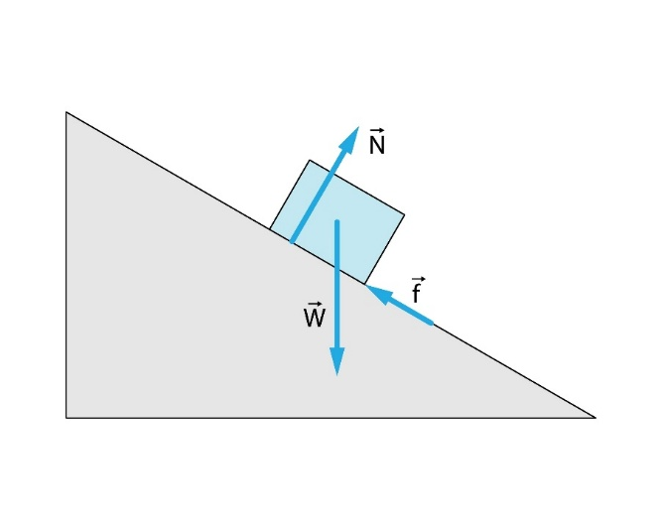

Q# | Correct | Misconception Identified by Incorrect Answers
1 | C | A: Equilibrium means no forces; B: Gravity is the only force.
2 | B | A/C: Motion implies a force (Impetus theory).
3 | C | A/B: Constant motion requires a constant resultant force.
4 | C | A/D: The "active" or "bigger" object exerts more force (Newton 3).
5 | B | A: Mass and Weight are the same; D: Mass/Weight are fixed.
6 | C | A/D: Gravity pulls heavy things faster; B: Impetus theory.
7 | B | A: Force is proportional to velocity (rather than acceleration).
8 | B | A/C: Passive objects (chairs/tables) don't exert forces.
9 | C | A/B: Motion requires a force to be maintained.
10 | B | A: Forces require contact; C: Air is needed to "carry" force.

Energy
1. The Nature of Energy
- Energy as a "Fuel" or "Stuff": The belief that energy is a physical substance or a liquid-like "juice" that flows through wires or lives inside batteries, rather than an abstract mathematical property of a system.
- Energy is "Used Up": The most common misconception; the idea that energy disappears or is "consumed" when a task is finished, rather than being dissipated into the surroundings.
- Energy and Force are the same: Using the terms interchangeably; not realizing that force is the mechanism of transfer, while energy is the capacity to do work.
- Only "Active" things have energy: The belief that energy only exists in things that are moving, hot, or making noise. Students often fail to recognize potential energy in a still object.
- Energy is "Created": The idea that a battery or a person "creates" energy from nothing when they start moving or working.
2. Energy Transfer and Transformation
- The "Switch" Model: Thinking energy stays in one place and then "switches" to another, rather than being a continuous flow or transfer between stores.
- Cold is a "thing": The belief that "cold" is a form of energy that moves into a house, rather than the absence or removal of thermal energy.
- Energy is only lost, never gained: Not understanding that "lost" energy (like friction) is actually just transferred to a less useful store (thermal energy in the surroundings).
- Batteries have "Electricity Energy": Failing to distinguish between the Chemical Store (inside the battery) and the Electric Pathway (the current in the wires).
- Energy stays in the source: The belief that a heater "keeps" its energy even as it warms up a room.
3. Thermal Energy and Heat
- Heat and Temperature are the same: Not realizing that temperature is the average kinetic energy of particles, while heat (thermal energy) depends on the total amount of "stuff."
- Some materials are "Inherently Cold": The idea that metal is "naturally colder" than wood, rather than metal simply being a better conductor that moves energy away from the hand faster.
- Insulators "Generate" Heat: Thinking that a coat or a blanket "makes" a person warm, rather than simply slowing down the transfer of energy from the body to the air.
- Boiling means 100°C only: The belief that energy is no longer being added once a liquid reaches its boiling point, or that the temperature continues to rise during the phase change.
- Radiation requires air: Thinking that thermal radiation (like the Sun's heat) needs air or a medium to travel through.
4. Potential and Kinetic Energy
- Potential energy is "stored motion": The belief that a ball on a shelf is "wanting" to move, rather than having energy due to its position in a gravitational field.
- Objects at rest have no energy: Ignoring the chemical, nuclear, or gravitational potential energy stored in stationary objects.
- Kinetic energy depends on height: Confusing the result of falling (gaining speed) with the cause (gravitational potential energy).
- Energy is only "Work": The idea that energy only exists if a human or machine is performing a visible task.
- Efficiency is about "Effort": Thinking a machine is "efficient" because it works hard, rather than it having a high ratio of useful energy output to total energy input.

Energy Diagnostic Quiz
Name: ___________________________ Date: _______________
Instructions: Circle the best answer for each question.
1. A battery-powered toy car runs across the floor until the battery "dies" and the car stops. What happened to the energy that was originally in the battery?
- A) It was used up and no longer exists.
- B) it was destroyed by the friction of the floor.
- C) It was transferred to the car's motion and then dissipated as heat to the surroundings.
- D) It went back into the battery to be reused later.
2. You hold a cup of hot cocoa in your hands on a cold day. Why do your hands feel warm?
- A) The cocoa is "giving" you its heat energy.
- B) The "cold" from your hands is moving into the cup.
- C) The cup is creating new energy because it is hot.
- D) Thermal energy is being destroyed as it moves into your skin.
3. Why do we put a coat on in the winter?
- A) The coat is a source of thermal energy that warms our body.
- B) The coat traps the air and slows down the transfer of energy from our body to the outside.
- C) The coat creates "heat" through the friction of the fabric.
- D) The coat attracts energy from the sun to keep us warm.
4. A ball is sitting perfectly still on a high shelf. Does it have energy?
- A) No, because it isn't moving.
- B) Yes, it has kinetic energy because it is high up.
- C) Yes, it has gravitational potential energy because of its position.
- D) No, energy only exists when the ball starts to fall.
5. When a light bulb is turned on, it gets hot as well as bright. Which statement is true about its efficiency?
- A) It is 100% efficient because all the energy is used for something.
- B) It is inefficient because some energy is "wasted" as thermal energy (heat).
- C) It is efficient because heat is a type of light.
- D) It is inefficient because the energy is being used up too fast.

6. If you touch a piece of metal and a piece of wood that have both been in the same room (at 20°C) for three days, why does the metal feel colder?
- A) Metal is naturally a colder material than wood.
- B) Metal is a better conductor and moves energy away from your hand faster.
- C) Wood generates its own internal heat.
- D) The metal has absorbed more "cold" from the air.
7. Which of the following is the best scientific description of "Work"?
- A) Being tired after thinking really hard about a physics problem.
- B) The process of energy being transferred by a force acting over a distance.
- C) The amount of "fuel" left in a system.
- D) Anything that requires a person to use their muscles.
8. What happens to the temperature of a pot of water while it is boiling vigorously?
- A) The temperature continues to rise until all the water is gone.
- B) The temperature stays the same because the energy is being used to break bonds/change state.
- C) The temperature drops because the steam carries the heat away.
- D) The temperature rises and falls as the bubbles move.
9. The Sun sends energy to the Earth through the vacuum of space. How does this energy travel?
- A) It travels as "heat" through the air particles in space.
- B) It travels as electromagnetic radiation (waves) which do not need particles.
- C) It is "pushed" to Earth by the Sun's gravity.
- D) It only becomes energy once it hits our atmosphere.
10. A "Conservation of Energy" law states that energy cannot be created or destroyed. If this is true, why are we told to "save energy" at home?
- A) Because energy eventually disappears if we use it too much.
- B) Because we are running out of energy in the universe.
- C) Because energy is transferred into non-useful stores (like heat in the air) that we can't use again.
- D) Because the law only applies in science labs, not in real houses.

Teacher’s Answer Key & Diagnostic Guide
Q# | Correct | Misconception Identified by Incorrect Answers
1 | C | A/B: Energy is "used up" or destroyed; D: Reversible energy.
2 | A | B: "Cold" is a substance; C: Energy is "created" by heat.
3 | B | A/C: Insulators "generate" or "provide" heat.
4 | C | A/D: Only moving things have energy; B: Potential/Kinetic confusion.
5 | B | A: Misunderstanding of "useful" vs "total" energy; D: Power vs Energy.
6 | B | A: Inherent temperature of materials; D: "Cold" absorption.
7 | B | A/D: Anthropomorphic/Colloquial definition of "Work."
8 | B | A: Temperature always rises when heating; C: Cooling effect of boiling.
9 | B | A: Radiation requires a medium/air; D: Energy requires a target.
10 | C | A/B: Energy is destroyed/finite; D: Science doesn't apply to real life.

Waves and Light
1. The Nature of Light and Sight
- The "Active Eye" (Outward Vision): The belief that we see because our eyes "send out" rays to look at objects, rather than light reflecting into the eye.
- Light travels "Instantly": The idea that light does not have a speed and just "is" everywhere at once.
- Light is a "Stuff": Viewing light as a physical material that fills a room like a gas, rather than an electromagnetic wave.
- The "Fading" Light: The belief that light only travels a certain distance and then just "stops" or disappears if it doesn't hit anything.
- Darkness is a Substance: Thinking that darkness is a "thing" that moves into a room, rather than the absence of light.
2. Reflection and Refraction
- Mirror images are "On" the mirror: The belief that the image is a flat picture on the glass surface, rather than located behind the mirror.
- Light only reflects from shiny things: Not realizing that we see non-shiny objects (like a wall) because they reflect light in many directions (diffuse reflection).
- Refraction is "Bending" the object: Thinking the object itself (like a straw in water) has physically broken or bent, rather than the light path changing.
- Shadows are "Cast" by the object: Seeing a shadow as a positive thing that an object "makes," rather than a region where light has been blocked.
- Colour is "In" the object: The belief that a red apple is red, rather than the apple reflecting red light and absorbing other colours.
3. Sound and Waves
- Waves transport matter: The belief that the water particles in a wave travel from the middle of the ocean to the shore (rather than just vibrating in place).
- Sound can travel in a vacuum: The idea that sound can travel through space (often reinforced by sci-fi movies).
- Pitch and Loudness are the same: Using the terms interchangeably; not distinguishing between frequency and amplitude.
- Matter "blocks" sound entirely: Not realizing that sound travels faster and more effectively through solids than through air.
- Waves "Die" out: Thinking waves lose energy because they are tired, rather than the energy spreading out or being absorbed.

4. The Electromagnetic Spectrum
- Radio waves are sound: The very common belief that radio waves are the actual sound waves coming out of a speaker.
- Gamma rays are always "Evil": The belief that all radiation is man-made and always harmful, ignoring natural background radiation or medical uses.
- Microwaves cook from the "Inside out": A myth; microwaves penetrate only a few centimetres and cook via the vibration of water molecules.
- Light and Radio are different things: Not realizing they are the same phenomenon (EM waves) at different frequencies.
- Transparent means "Nothing": Thinking that glass or water has no effect on light because we can see through it.
Waves and Light Diagnostic Quiz
Name: ___________________________ Date: _______________
Instructions: Circle the best answer for each question.
1. How do you see a book sitting on a desk in a room with a lamp?
- A) Your eyes send out "sight rays" that hit the book.
- B) The book creates its own light so you can see it.
- C) Light from the lamp reflects off the book and enters your eyes.
- D) The light from the lamp fills the room and stays there.
2. If you are standing 1 meter in front of a flat mirror, where is your image located?
- A) On the surface of the glass.
- B) 1 metre behind the mirror.
- C) 1 meter in front of the mirror, between you and the glass.
- D) Inside your own eyes.
3. Why does a straw look "broken" when you put it into a glass of water?
- A) The weight of the water pushes the straw until it bends.
- B) The light changes speed and direction as it moves from water to air.
- C) Water acts as a magnifying glass that enlarges the bottom half.
- D) The straw is physically bent by the surface tension.
4. A tree casts a shadow on the ground on a sunny day. What is a shadow?
- A) A dark "reflection" made by the tree.
- B) A region where light from the sun has been blocked by the tree.
- C) A substance that the tree spreads on the ground.
- D) The "cold" part of the ground.
5. What happens to the particles of water as a wave passes through them in the open ocean?
- A) They travel with the wave all the way to the beach.
- B) They stay in the same general place, moving up and down or in small circles.
- C) They disappear and are replaced by new particles.
- D) They move in the opposite direction of the wave.

6. If a giant explosion happened in deep space, why would a nearby astronaut see it but not hear it?
- A) Space is too cold for sound to move.
- B) Sound waves need particles (a medium) to travel, and space is a vacuum.
- C) The astronaut’s helmet blocks sound but lets in light.
- D) The light moves so fast that the sound can't catch up.
7. Why does a red shirt look red when "white" sunlight hits it?
- A) The shirt adds red energy to the light.
- B) The shirt absorbs red light and reflects all other colours.
- C) The shirt reflects the red part of the white light and absorbs the other colours.
- D) White light doesn't have colours in it until it hits the shirt.
8. Which of the following is true about "Radio Waves"?
- A) They are a type of sound wave that travels through the air.
- B) They are a type of light (electromagnetic wave) that we cannot see.
- C) They only exist inside a radio or a cell phone.
- D) They travel much slower than the speed of light.
9. When you turn off a light in a room, where does the light go?
- A) It is absorbed by the walls and furniture and turned into a tiny amount of heat.
- B) It stays in the air but becomes too dim to see.
- C) It flows back into the light bulb.
- D) It just disappears and ceases to exist.
10. In a wave, "Frequency" refers to:
- A) How tall the wave is.
- B) How many waves pass a point every second.
- C) How much energy the wave started with.
- D) How far the wave travels before it stops.

Teacher’s Answer Key & Diagnostic Guide
Q# | Correct | Misconception Identified by Incorrect Answers
1 | C | A: Outward vision/Sight rays; B: Non-luminous objects emit light.
2 | B | A: Image is on the surface; C/D: Image location confusion.
3 | B | A/D: Physical bending of the object; C: General "magnification."
4 | B | A/C: Shadow as a "thing" or a "reflection."
5 | B | A: Waves transport matter/particles.
6 | B | B: Sound can travel in a vacuum; D: Speed vs. Medium.
7 | C | B: Absorption vs. Reflection confusion; D: Nature of white light.
8 | B | A: Radio waves are sound waves.
9 | A | B/D: Light is a "stuff" that stays in air or disappears.
10 | B | A: Frequency vs. Amplitude; C/D: General wave properties.

Matter and Kinetic Theory
1. The Nature of Particles
- Particles are like the bulk substance: The belief that individual atoms of gold are shiny/yellow, or that particles of water are "wet" or "liquid."
- Matter is continuous: The idea that even if you zoom in forever, matter is just a solid "stuff" with no empty space between particles.
- Particles change size: Thinking that particles expand when heated or shrink when cooled, rather than just moving further apart.
- Particles can "die" or disappear: The belief that when a substance evaporates or dissolves, the particles cease to exist.
- There is "air" between particles: The misconception that the space between atoms or molecules is filled with air, rather than being a vacuum (nothingness).
2. States of Matter and Phase Changes
- Gases have no mass: The belief that air or steam weighs nothing, or even has "negative weight" because it floats.
- Freezing must be cold: Thinking that "freezing" only happens at 0 degrees celsius or below, not realizing that iron "freezes" into a solid at 1538 degrees celsius.
- Boiling bubbles are air: The idea that the bubbles in boiling water are made of air or "heat," rather than being water in the gaseous state (steam).
- Evaporation only happens at 100 degrees celsius: Not realizing that evaporation is a surface phenomenon that happens at any temperature.
- Solids don't move: The belief that particles in a solid are perfectly still, rather than vibrating around a fixed point.
3. Expansion and Density
- Density is the same as Weight: Thinking a large piece of wood is "denser" than a small copper coin because the wood is heavier overall.
- Expansion is caused by "Heat Particles": The idea that heat is a physical substance (caloric) that enters an object and takes up space, pushing the atoms apart.
- Particles "sink" when they get cold: Believing that individual particles become "heavier" when cooled, rather than the substance becoming denser as a whole.
- Floating is only about weight: The idea that heavy things always sink and light things always float, regardless of volume.
- Compressed gas is "stronger": Thinking that the particles in a compressed gas are harder or "more squashed" themselves.

4. Diffusion and Dissolving
- Dissolving is the same as Melting: The very common belief that sugar "melts" in tea (which requires heat) rather than dissolving (which requires a solvent).
- The "Disappearing" Solute: Thinking that when sugar dissolves, it turns into a liquid or simply "vanishes," leaving only the taste behind.
- Diffusion requires "Wind": The idea that smells or dyes only spread because of air or water currents, rather than the random internal motion of particles.
- Mass is lost during dissolving: The belief that 10g of salt in 100g of water will weigh less than 110g because the salt "disappeared."
- Particles move "Purposefully": Thinking that particles move toward a specific area because they "know" there is more room there.
Matter Diagnostic Quiz
Name: ___________________________ Date: _______________
Instructions: Circle the best answer for each question.
1. If you could see the "space" between two atoms of gold in a solid ring, what would be in that space?
- A) Air.
- B) Liquid gold.
- C) Nothing (a vacuum).
- D) Heat energy.
2. A sealed metal canister is filled with air and heated up. What happens to the actual particles (molecules) of air inside?
- A) The individual particles expand and get larger.
- B) The particles move faster and hit the walls harder.
- C) The particles melt into a liquid state.
- D) New particles are created by the heat.
3. When water is boiling in a pot on a stove, what is inside the bubbles that are rising to the surface?
- A) Air that was trapped in the water.
- B) Pure heat.
- C) Water in the form of a gas (water vapor).
- D) Hydrogen and Oxygen gas that have split apart.
4. A student dissolves 5 grams of sugar into 100 grams of water. What is the final mass of the sugar-water solution?
- A) 100 grams, because the sugar has disappeared.
- B) 105 grams, because the particles are still there but hidden.
- C) 95 grams, because some water evaporated.
- D) 5 grams, because the water doesn't count once it has sugar in it.
5. Why can you smell a pizza in the next room even if there is no fan or breeze blowing?
- A) The smell particles have a "desire" to fill the house.
- B) The smell particles are moving randomly and bumping into each other until they spread out.
- C) The air in the room turns into "smell" energy.
- D) Heat pushes the particles in a straight line toward your nose.
6. Which statement best describes the particles in a solid block of ice?
- A) They are perfectly still and do not move at all.
- B) They are vibrating back and forth around fixed positions.
- C) They are floating in a very thin layer of water.
- D) They are constantly swapping places with each other.
7. If you have a 1kg block of lead and a 1kg bag of feathers, which one is denser?
- A) They have the same density because they weigh the same.
- B) The lead, because the same mass is packed into a much smaller volume.
- C) The feathers, because they take up more space.
- D) Density depends on the temperature, not the material.
8. What is the difference between "melting" and "dissolving"?
- A) They are two different words for the same thing.
- B) Melting requires heat to change state; dissolving requires a liquid to break particles apart.
- C) Dissolving only happens to food; melting only happens to ice.
- D) Melting makes things disappear, while dissolving keeps them visible.
9. Why does a balloon full of air weigh more than an empty, uninflated balloon?
- A) It doesn't; the full balloon is lighter because air floats.
- B) Because the air inside has mass, even though it is a gas.
- C) Because the rubber is stretched thinner.
- D) Because the person who blew it up added "heavy" breath.
10. When an iron bar is heated and it expands (gets longer), what is happening?
- A) The atoms are getting bigger.
- B) The atoms are vibrating more and pushing each other further apart.
- C) The heat is adding a layer of "fire" between the atoms.
- D) The bar is absorbing air from the room.

Teacher’s Answer Key & Diagnostic Guide
Q# | Correct | Misconception Identified by Incorrect Answers
1 | C | A: "Air fills space" model; D: Energy is a physical substance.
2 | B | A: Particles themselves expand; D: Heat creates matter.
3 | C | A: Bubbles are air; B: Bubbles are "heat."
4 | B | A: Matter disappears when dissolved (Loss of mass).
5 | B | A: Purposeful motion; D: Convection/Force required for diffusion.
6 | B | A: Static particle model for solids.
7 | B | A: Density = Weight; C: Density = Volume.
8 | B | B: Confusion between melting (thermal) and dissolving (chemical).
9 | B | A: Gases have no mass / Gases are "buoyant."
10 | B | A: Atomic expansion; C: Caloric (substance) theory of heat.

Space and Astronomy
1. The Earth, Moon, and Sun
- The Earth is closer to the Sun in Summer: The belief that seasons are caused by distance rather than the tilt of the Earth’s axis.
- The Moon produces its own light: Thinking the Moon is like a star, rather than a rock reflecting sunlight.
- The Phases are caused by Earth's shadow: Confusing "Phases of the Moon" with a "Lunar Eclipse."
- The Sun "goes over" the Earth: The belief that the Sun physically moves across the sky while the Earth stays still.
- The Earth is the centre of the Universe: A lingering "Geocentric" view where everything orbits us.
2. Gravity in Space
- Zero Gravity in Orbit: The belief that astronauts float because there is "no gravity" in space, rather than because they are in constant "free-fall."
- Gravity needs air: The idea that gravity stops as soon as you leave the Earth's atmosphere.
- The Sun's gravity only affects planets: Thinking the Sun doesn't pull on distant stars or that its pull stops at Pluto.
- Planets "stay up" because of no gravity: The idea that planets would fall "down" if gravity existed in space.
3. Stars and the Solar System
- Stars are "Close": Thinking stars are just outside our Solar System, rather than light-years away.
- The North Star is the brightest: A common myth; it is actually quite dim (Polaris is the 48th brightest star).
- Shooting Stars are actual Stars: Not realizing they are tiny grains of dust (meteors) burning up in our atmosphere.
- The Solar System is "Crowded": Based on textbook diagrams, students think planets are very close together (ignoring the vast scale of empty space).
4. The Big Bang and Light
- The Big Bang was an "Explosion": Thinking it was an explosion in space (like a bomb), rather than an expansion of space itself.
- We see events "Now": Not realizing that because of the speed of light, looking at distant stars is actually "looking back in time."
- Black Holes are "Vacuum Cleaners": The belief that black holes "suck" everything in from great distances, rather than just having a very strong gravitational pull nearby.

Space Diagnostic Quiz
Name: ___________________________ Date: _______________
1. Why is it hotter in the Summer than in the Winter?
- A) The Earth is physically closer to the Sun in the Summer.
- B) The Earth's tilt means the Sun's rays hit the ground more directly.
- C) The Sun burns brighter during the summer months.
- D) The Earth spins faster in the summer, creating more heat.
2. What causes the different "Phases" of the Moon (New Moon, Half Moon, etc.)?
- A) The Earth casts a shadow on the Moon.
- B) The Moon moves into the shadow of other planets.
- C) We see different amounts of the Moon's sunlit side as it orbits Earth.
- D) Clouds in space block out parts of the Moon.
3. If an astronaut is "floating" inside the International Space Station, is gravity acting on them?
- A) No, because they are outside the Earth's atmosphere.
- B) No, because they are too far away from Earth.
- C) Yes, gravity is pulling them, but they are falling "around" the Earth.
- D) Yes, but only the gravity from the Moon.
4. Which statement about the Sun is correct?
- A) The Sun is a planet made of fire.
- B) The Sun is a star that reflects light from other stars.
- C) The Sun is an average-sized star that produces its own light.
- D) The Sun is the largest object in the entire Universe.
5. How far away are the stars we see in the night sky?
- A) Just beyond the clouds.
- B) Roughly the same distance as the Moon.
- C) Many billions of kilometres away (light-years).
- D) On the edge of our atmosphere.

6. What is a "Shooting Star"?
- A) A star that has died and is falling to Earth.
- B) A small piece of rock or dust burning up in Earth's atmosphere.
- C) A planet moving very quickly.
- D) A piece of the Sun that broke off.
7. If the Sun suddenly disappeared, how long would it take for people on Earth to notice the sky go dark?
- A) Instantly.
- B) About 8 minutes.
- C) About 24 hours.
- D) One year.
8. What is the "Space" between planets mostly made of?
- A) Very thin air.
- B) Dark clouds of smoke.
- C) A vacuum (almost nothing).
- D) Liquid energy.

9. What keeps the planets in our Solar System moving in circles around the Sun?
- A) They are attached to invisible "strings" of energy.
- B) The gravitational pull of the Sun.
- C) The wind in space pushes them.
- D) They are moving so fast they can't stop.
10. When we look at a star that is 100 light-years away, what are we seeing?
- A) The star as it looks right now.
- B) The star as it looked 100 years ago.
- C) A prediction of what the star will look like in the future.
- D) A reflection of the Earth.

Teacher’s Answer Key
Q# | Correct | Misconception Identified by Incorrect Answers
1 | B | A: Seasons caused by distance; C: Sun's output changes.
2 | C | A: Confusion between Phases and Eclipses.
3 | C | A/B: "No gravity in space" myth.
4 | C | A: Sun as a planet; B: Sun as a reflector.
5 | C | A/D: Stars are within the atmosphere/nearby.
6 | B | A: Meteors are falling stars.
7 | B | A: Light travels instantly.
8 | C | A: Space is filled with air.
9 | B | A/D: Motion doesn't require a central force (Newton 1 confusion).
10 | B | A: Instantaneous vision over vast distances.

Radioactivity and Ionizing Radiation
1. The Nature of Radiation
- Radiation is "Contagious": The belief that if you are exposed to radiation (like an X-ray), you become radioactive yourself and can "infect" others.
- Radiation is a "Glowing Gas": Thinking radiation is a green, glowing mist that hangs in the air, rather than invisible high-energy particles or waves.
- Radioactivity is only Man-Made: Ignoring natural background radiation from rocks, cosmic rays, and food (like bananas), and believing it only comes from power plants or bombs.
- All Radiation is Lethal: Not distinguishing between non-ionizing radiation (radio/microwaves) and ionizing radiation (alpha, beta, gamma).
- Radiation "Wears Off" like a Smell: The idea that you can "wash off" radiation exposure from your body (confusing exposure with contamination).
2. Atoms and Decay
- Decay makes atoms disappear: The belief that after an atom decays, nothing is left, rather than it changing into a different, more stable element.
- Half-life is the "Total Life": Thinking that if the half-life is 10 years, the substance will be completely gone in 20 years.
- Atoms "Choose" when to decay: The idea that older atoms are more likely to decay than younger ones, failing to realize it is a purely random process.
- Nuclear Power is a "Small Bomb": The belief that a nuclear reactor can explode like an atomic bomb (which is physically impossible due to the grade of fuel used).

Radioactivity Diagnostic Quiz
Name: ___________________________ Date: _______________
1. A person goes to the hospital for a chest X-ray. When they leave the room, are they radioactive?
- A) Yes, they will emit X-rays for several hours.
- B) No, they were exposed to radiation but do not become a source of it.
- C) Only if they breathed in the X-ray light.
- D) Yes, they must stay away from children for 24 hours.
2. Which of the following is the largest source of radiation for the average person?
- A) Nuclear power plants.
- B) Proximity to cell phone towers.
- C) Natural background radiation (radon gas, rocks, cosmic rays).
- D) Leftover fallout from historical bomb tests.
3. If a radioactive sample has a "Half-life" of 1 hour, what happens after 2 hours?
- A) The sample is completely gone.
- B) One-quarter (25%) of the original radioactive atoms remain.
- C) The sample becomes twice as dangerous.
- D) The atoms stop decaying and become stable.
4. What is actually happening during "Alpha Decay"?
- A) An atom is "burning up" and turning into heat.
- B) The nucleus of an atom emits a particle consisting of two protons and two neutrons.
- C) The atom is splitting into two equal halves.
- D) Electrons are being shared with a neighbouring atom.
5. Why is "Ionizing Radiation" (like Gamma rays) considered dangerous to living cells?
- A) It makes the cells turn green and glow.
- B) It has enough energy to knock electrons off atoms, damaging DNA.
- C) It makes the cells move too fast.
- D) It causes the cells to freeze instantly.

Teacher’s Answer Key
Q# | Correct | Misconception Identified
1 | B | A/D: Confusion between Exposure and Contamination.
2 | C | A/B: Belief that all radiation is man-made/industrial.
3 | B | A: Linear thinking regarding half-life.
4 | B | A/C: Decay as "disappearing" or "burning."
5 | B | B: Identifying the mechanism of ionization vs. "magic" damage.

